# Objective

This tutorial provides instructions and suggestions based on the [PIPPY Documentation](https://www.waveshare.net/wiki/PIPPY). This tutorial is not necessary but beneficial. You should complete the software installation and component assembling after this tutorial.

# Basic Knowledge

Before start, you should have a basic understanding of some protocols and concepts:

# OS

The operational system is the program that manages the device’s resources. Windows, Linux, and Raspbian OS are all operational systems.

# IP

A device may have not only one IP address because of the existence of intranet and extranet. If the devices in the same intranet want to communicate with others, the intranet IP is required, and vice versa.

# Port (logic port)

A device runs a lot of network services. Ports are used to avoid conflicts between different services. Some protocols have their default port: http-80, https-443, mysql-3306.

# SSH

Secure Shell (SSH) is a Network Security Protocol which commonly used in Linux. You can consider it as a remote terminal with remote login and file transfer. The default port of SSH is 22.

# VNC

Virtual Network Computing (VNC) is a remote desktop control tool based on Linux. The default port of VNC is 5900.

# Instructions and Suggestions

# First WLAN connection

In the video, it uses two files to enable WLAN and SSH. But it is not reliable. If you make any mistake when writing the wpa_supplicant file, you cannot modify it. Because Raspi only accepts it once. If you want to change it, you must reinstall the whole OS. So, the best way is to use an HDMI cable and set up the configuration on the desktop.

Besides, do not connect the WLAN that is used on campus (public/portal/secure). These WLANs cannot provide a general intranet. Use the WLAN provided by the laboratory or your own access point.

# Use static IP address

Occasionally, the intranet IP will change due to the router (the intranet IP of routers will not change). So, it is recommended to use static IP to avoid such problems. The Local Area Network Intranet has the range of:

192.168.0.0~192.168.255.255

So, the IP of Raspi will be like:

192.168.???.!!!

“???” is decided by the router. And you can assign the number of “!!!”

1. Find “???”, type the command, and find out the first 3 sections of intranet IP in the terminal:

ifconfig

1. Find Network Settings:

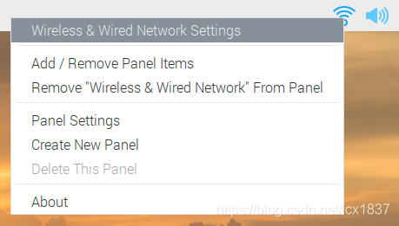

1. Set static IP for WLAN or ethernet (Here assume you find that “???” is “0”. And you set “100” as “!!!”)

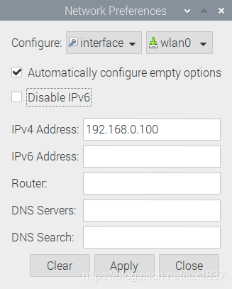

1. DO NOT use the same intranet IP! Set different addresses for different devices. And, do not forget to inform other classmates of the IP addresses you have used!

# Use SSH

If you want to use SSH as a Raspi remote terminal. Make sure you have enabled SSH in Raspi. Make sure two devices are on the same intranet. Then use the command below to connect on your computer:

ssh <user name>@<Raspi IP>

Then, type in the password, so you can log in to your Raspi.

# Use VNC

If you are not familiar with the Linux command, VNC is a better solution.

1. First, make sure that you have enabled VNC in Raspi.
2. Then you should download a VNC Viewer on your computer.
3. Launch VNC Viewer, right click and create a new connection.

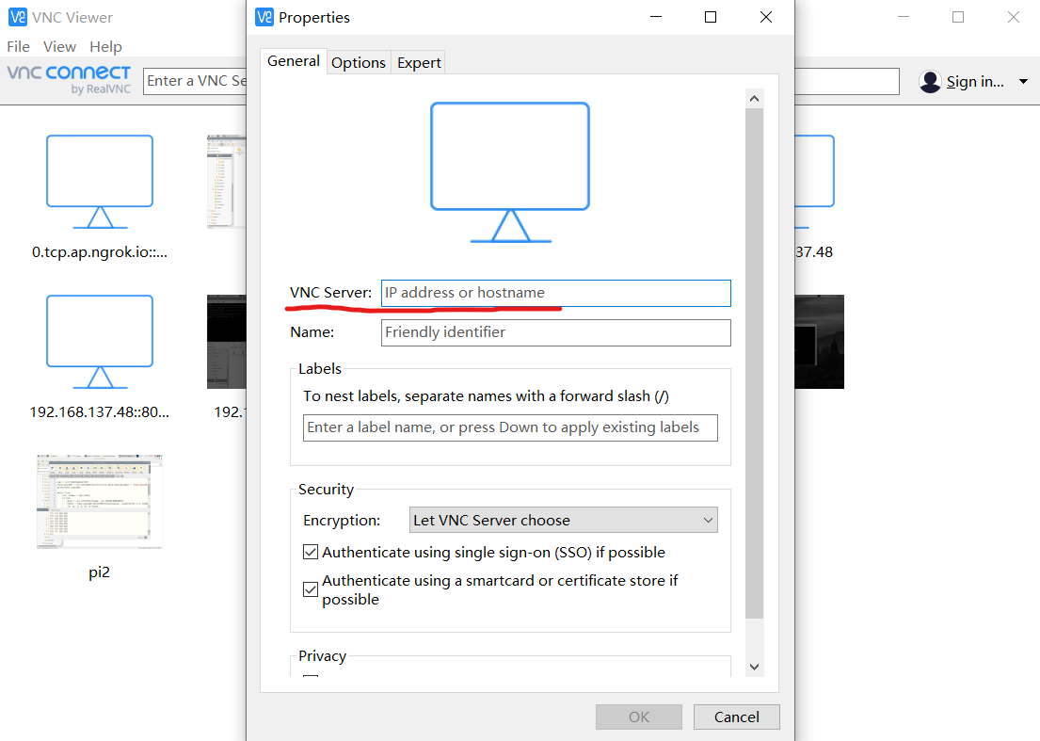

1. Just type in the IP of Raspi, then name it as whatever you want, and click “ok”.
2. Double-click the connection you created.
3. If everything goes right, a window will pop up. And you just enter the Raspi username and password, so you could log in.
4. If you have logged in but the VNC Viewer shows: “cannot currently show the desktop”. You should adjust the resolution of Raspi. Search on the Internet and you will find the solution.

# Assembling

The legs of the PIPPY dog are flimsy. Watch the video carefully and check the steps before you adjust the leg!!!

# Reference

1. [PIPPY - Waveshare Wiki](https://www.waveshare.net/wiki/PIPPY)
2. [(14条消息) 树莓派设置静态 IP（固定 IP）_树莓派固定ip_~莘莘的博客-CSDN博客](https://blog.csdn.net/lcx1837/article/details/118332954)
3. [(14条消息) 树莓派入门操作及VNC显示 cannot currently show the desktop 解决方法_Jacen_L的博客-CSDN博客](https://blog.csdn.net/LlHilo/article/details/106577069)

# End of Tutorial